Types of Spelling Dictionaries
# Source: AI Source: Provided by: [Data Path: Persons Table -> ID Column: 1, Name_En Column: Motasem Essam] -> From: [Chatgpt (GPT-4-turbo)] on [7/30/2025]
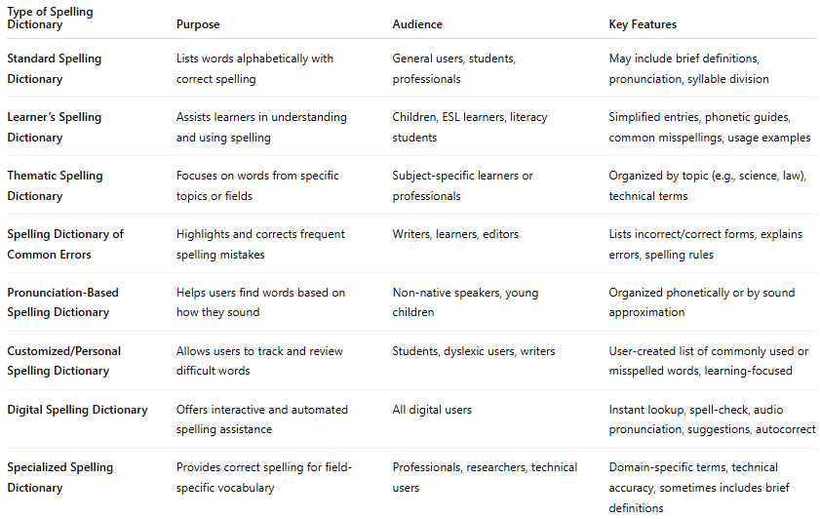

Type of Spelling Dictionary | Purpose | Audience | Key Features
Standard Spelling Dictionary | Lists words alphabetically with correct spelling | General users, students, professionals | May include brief definitions, pronunciation, syllable division
Learner’s Spelling Dictionary | Assists learners in understanding and using spelling | Children, ESL learners, literacy students | Simplified entries, phonetic guides, common misspellings, usage examples
Thematic Spelling Dictionary | Focuses on words from specific topics or fields | Subject-specific learners or professionals | Organized by topic (e.g., science, law), technical terms
Spelling Dictionary of Common Errors | Highlights and corrects frequent spelling mistakes | Writers, learners, editors | Lists incorrect/correct forms, explains errors, spelling rules
Pronunciation-Based Spelling Dictionary | Helps users find words based on how they sound | Non-native speakers, young children | Organized phonetically or by sound approximation
Customized/Personal Spelling Dictionary | Allows users to track and review difficult words | Students, dyslexic users, writers | User-created list of commonly used or misspelled words, learning-focused
Digital Spelling Dictionary | Offers interactive and automated spelling assistance | All digital users | Instant lookup, spell-check, audio pronunciation, suggestions, autocorrect
Specialized Spelling Dictionary | Provides correct spelling for field-specific vocabulary | Professionals, researchers, technical users | Domain-specific terms, technical accuracy, sometimes includes brief definitions

